Quiz 2

Time series Modelling

**1) Which of the following is an example of time series problem?**

**1. Estimating number of hotel rooms booking in next 6 months.**  
**2. Estimating the total sales in next 3 years of an insurance company.**  
**3. Estimating the number of calls for the next one week.**

A) Only 3  
B) 1 and 2  
C) 2 and 3  
D) 1 and 3  
E) 1,2 and 3

**2) Which of the following is relatively easier to estimate in time series modeling?**

A) Seasonality  
B) Cyclical  
C) No difference between Seasonality and Cyclical

**3) Adjacent observations in time series data (excluding white noise) are independent and identically distributed (IID).**

A) TRUE

B) FALSE

4) **Smoothing parameter close to one gives more weight or influence to recent observations over the forecast.**

A)TRUE  
B) FALSE

**5) The last period’s forecast was 70 and demand was 60. What is the simple exponential smoothing forecast with alpha of 0.4 for the next period.**

A)63.8  
B) 65  
C) 62  
D) 66

**6) What does autocovariance measure**?

A) Linear dependence between multiple points on the different series observed at different times  
B)Quadratic dependence between two points on the same series observed at different times  
C) Linear dependence between two points on different series observed at same time  
D) Linear dependence between two points on the same series observed at different times

**7) Which of the following is not a necessary condition for weakly stationary time series?**

A) Mean is constant and does not depend on time  
B) Autocovariance function depends on s and t only through their difference |s-t| (where t and s are moments in time)  
C) The time series under considerations is a finite variance process  
D) Time series is Gaussian

**8) If the demand is 100 during October 2016, 200 in November 2016, 300 in December 2016, 400 in January 2017. What is the 3-month simple moving average for February 2017?**

A) 300  
B) 350  
C) 400  
D) Need more information

**9) Looking at the below ACF plot, would you suggest to apply AR or MA in ARIMA modeling technique?**

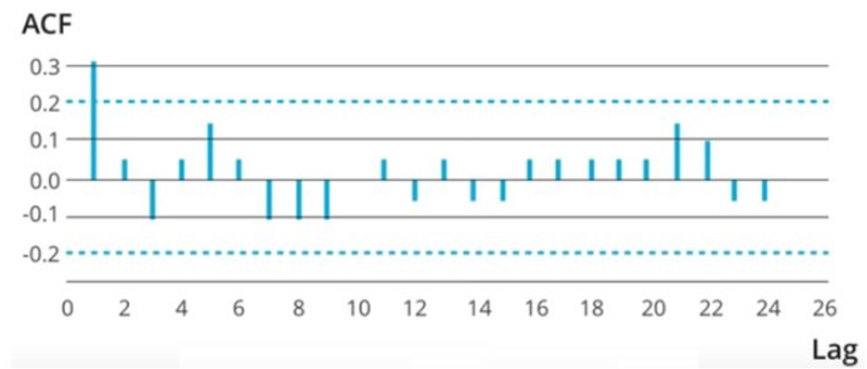  
A) AR  
B) MA  
C) Can’t Say

**10) Imagine, you are working on a time series dataset. Your manager has asked you to build a highly accurate model. You started to build two types of models which are given below.**

**Model 1: Decision Tree model**

**Model 2: Time series regression model**

**At the end of evaluation of these two models, you found that model 2 is better than model 1. What could be the possible reason for your inference?**

A) Model 1 couldn’t map the linear relationship as good as Model 2  
B) Model 1 will always be better than Model 2  
C) You can’t compare decision tree with time series regression  
D) None of these